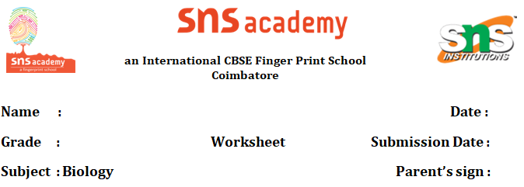
THE FUNDAMENTAL UNIT OF LIFE
1.
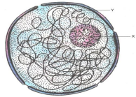
a. Identify the above figure.
b. Label X and Y.
c. What is the function of X?
2. What will happen if
a. Excess amount of fertilizer is added to green grass lawn.
b. Salt is added to cut pieces of raw mango?
3.
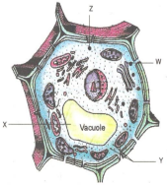
a. Label W, X , Y and Z
b. What is the covering membrane of X known as?
c. Which of them contains hydrolytic enzymes?
d. Which one of them takes part in storage, modification and packaging of various chemicals?
4. What will happen if chloroplast is taken out of the cell and illuminated?
5.
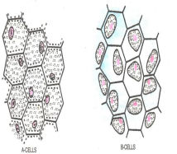
a. Identify A and B cells.
b. What will happen if B cells are kept in hypotonic solution?
c. What will happen if A cells are kept in hypertonic solution?
6.
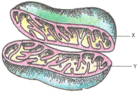
a. Label X and Y
b. What is the function of X?
c. What is the composition of Y?
d. Identify the above diagram and what is its common name?
7. Match the columns A, B, & C
A | B |  | C
Mitochondria | Sedimentation coefficient | Spindle fibers
Golgi bodies | Hydrolytic enzyme | Power house
Lysosomes | Axoneme | Cisternae
Ribosomes | Centrioles | Acidic PH
Cilia | Glycoproteins | George Palade
Centrosome | Cristae | 9+ 2

8. Bacterial cell envelope is having a complex structure. Name the layers of the envelope.
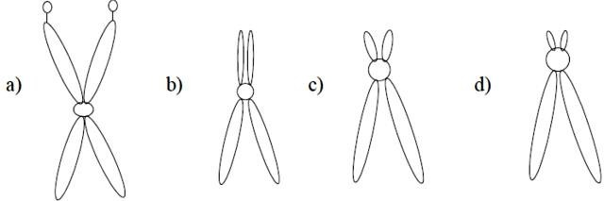
9. Types of Chromosomes based on the position of centromere are given. Name the Chromosomes.

10. In cells glycoprotein & glycolipids are secreted by a cell organelle.
a. Name the cell organelle
b. Neatly draw its diagram
11. Plastids are found in all plant cells
a. List the three plastids found in plants.
b. Name the colourless plastids and specify its role.
12. Identify the characters of prokaryotic cells from the following statements
a. Endoplasmic reticulum present b. Ribosome present
c. Golgi bodies absent d. Incipient nucleus
e. Yeast is an example f. Mostly anaerobes
13. Golgi apparatus remains in close association with the endoplasmic reticulum. Give the reason.
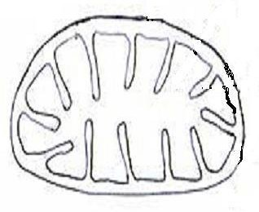
14. Copy the following diagram and label the parts.
15. If cells of onion peel and RBC are separately kept in hypotonic solution, what will happen to each of them? Explain the reason for your answer.
(a) Both the cells will swell.
(b) RBC will burst easily while cells of onion peel will resist the bursting to some extent.
(c) (a) and (b) both are correct.
(d) RBC and onion peel cells will behave similarly

